3.Scenario: You are working on a project that involves analyzing a dataset containing information about houses in a neighborhood. The dataset is stored in a CSV file, and you have imported it into a NumPy array named house_data. Each row of the array represents a house, and the columns contain various features such as the number of bedrooms, square footage, and sale price.

Question: Using NumPy arrays and operations, how would you find the average sale price of houses with more than four bedrooms in the neighborhood?

**CODE:**

import numpy as np

import pandas as pd

df = pd.read_csv('house_data.csv')

house_data = df.to_numpy()

bedrooms = house_data[:, 0]

sale_prices = house_data[:, 2]

mask = bedrooms > 4

filtered_sale_prices = sale_prices[mask]

average_price = np.mean(filtered_sale_prices)

print(f"Average sale price of houses with more than 4 bedrooms: {average_price:.2f}")

**OUTPUT:**

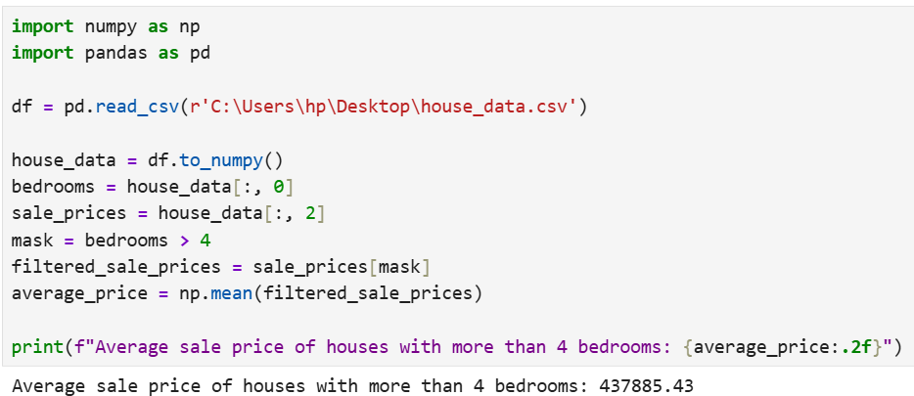

**DATASET:**

|  |  |  |  |  |  |
| --- | --- | --- | --- | --- | --- |
| Bedrooms | Square_Footage | Sale_Price | |  |  |
| 7 | 4598 | 732953.4 |  |  |  |
| 4 | 2075 | 334525.7 |  |  |  |
| 5 | 1816 | 219051.3 |  |  |  |
| 7 | 1137 | 137367.1 |  |  |  |
| 3 | 1678 | 297451.3 |  |  |  |
| 5 | 1876 | 313212.3 |  |  |  |
| 5 | 4793 | 686864.8 |  |  |  |
| 7 | 1179 | 164320 |  |  |  |
| 2 | 1292 | 187686.2 |  |  |  |
| 3 | 2862 | 462496.7 |  |  |  |
| 7 | 4684 | 768887.3 |  |  |  |
| 3 | 864 | 133590.8 |  |  |  |
| 3 | 3368 | 566421.7 |  |  |  |
| 5 | 2827 | 470033.6 |  |  |  |
| 4 | 3495 | 537398 |  |  |  |
| 3 | 2295 | 273957.5 |  |  |  |
| 6 | 1191 | 128240.9 |  |  |  |
| 5 | 4361 | 694787.5 |  |  |  |
| 2 | 3078 | 378697.1 |  |  |  |
| 4 | 3899 | 593995.6 |  |  |  |
| 6 | 1000 | 200844.2 |  |  |  |
| 6 | 3904 | 596421.9 |  |  |  |
| 2 | 3254 | 460698 |  |  |  |
| 4 | 4445 | 628063.6 |  |  |  |
| 5 | 1604 | 282722.7 |  |  |  |
| 1 | 3531 | 556130.4 |  |  |  |
| 4 | 3573 | 524605 |  |  |  |
| 2 | 2370 | 410707.7 |  |  |  |
| 6 | 3490 | 569061.3 |  |  |  |
| 5 | 4640 | 789233.9 |  |  |  |
| 4 | 1828 | 304043.4 |  |  |  |
| 1 | 1302 | 188142.5 |  |  |  |
| 1 | 1670 | 244719.7 |  |  |  |
| 3 | 1006 | 54996.29 |  |  |  |
| 3 | 2284 | 352005.6 |  |  |  |
| 7 | 1663 | 250027.7 |  |  |  |
| 2 | 3590 | 474939.7 |  |  |  |
| 4 | 1363 | 204303.1 |  |  |  |
| 4 | 4991 | 819900.4 |  |  |  |
| 7 | 2557 | 348919 |  |  |  |
| 6 | 2478 | 325736.9 |  |  |  |
| 6 | 4042 | 664860.4 |  |  |  |
| 7 | 1859 | 312086.2 |  |  |  |
| 6 | 2522 | 533422.5 |  |  |  |
| 3 | 4114 | 554544.5 |  |  |  |
| 4 | 3957 | 632813.6 |  |  |  |
| 7 | 3425 | 532352.6 |  |  |  |
| 4 | 3529 | 535207.4 |  |  |  |
| 1 | 2397 | 407040.9 |  |  |  |
| 3 | 3860 | 580678.5 |  |  |  |
| 5 | 3493 | 429995 |  |  |  |
| 3 | 4427 | 625311.7 |  |  |  |
| 7 | 2163 | 394445.1 |  |  |  |
| 5 | 2781 | 478031.5 |  |  |  |
| 1 | 2463 | 352813.4 |  |  |  |
| 7 | 2329 | 376439.4 |  |  |  |
| 2 | 2838 | 567223.7 |  |  |  |
| 4 | 4102 | 617103.8 |  |  |  |
| 1 | 3037 | 457460.8 |  |  |  |
| 4 | 2106 | 327156.6 |  |  |  |
| 6 | 4829 | 758658 |  |  |  |
| 2 | 3475 | 506654 |  |  |  |
| 2 | 2082 | 344313.5 |  |  |  |
| 1 | 1509 | 130375.7 |  |  |  |
| 2 | 4548 | 702748.7 |  |  |  |
| 5 | 1463 | 223181 |  |  |  |
| 2 | 2798 | 411121.2 |  |  |  |
| 4 | 4245 | 616467.5 |  |  |  |
| 4 | 4543 | 654706 |  |  |  |
| 7 | 2295 | 305455.6 |  |  |  |
| 4 | 4104 | 503061.4 |  |  |  |
| 7 | 4563 | 674790.2 |  |  |  |
| 4 | 2653 | 454941.6 |  |  |  |
| 5 | 2091 | 298593.8 |  |  |  |
| 7 | 4381 | 692497.5 |  |  |  |
| 3 | 4257 | 588030.2 |  |  |  |
| 6 | 2436 | 302112.3 |  |  |  |
| 1 | 4496 | 640548.1 |  |  |  |
| 4 | 3799 | 521689.7 |  |  |  |
| 2 | 3952 | 536888.2 |  |  |  |
| 4 | 1498 | 248416.9 |  |  |  |
| 2 | 2960 | 535373.1 |  |  |  |
| 6 | 4897 | 705217.8 |  |  |  |
| 6 | 1654 | 164865.2 |  |  |  |
| 6 | 4274 | 677444 |  |  |  |
| 2 | 2507 | 306310.4 |  |  |  |
| 4 | 3577 | 480319.4 |  |  |  |
| 6 | 2533 | 406776.5 |  |  |  |
| 5 | 4310 | 641768.2 |  |  |  |
| 7 | 1002 | 116762.8 |  |  |  |
| 2 | 4055 | 614992.2 |  |  |  |
| 2 | 1566 | 215713.5 |  |  |  |
| 4 | 3127 | 566091.1 |  |  |  |
| 2 | 3731 | 528918.7 |  |  |  |
| 2 | 997 | 104696.8 |  |  |  |
| 6 | 2730 | 388986.6 |  |  |  |
| 4 | 4382 | 640254.6 |  |  |  |
| 6 | 1408 | 242136.6 |  |  |  |
| 7 | 4072 | 514561.7 |  |  |  |
| 7 | 1947 | 314947.6 |  |  |  |